FreeCAD to OpenEMS export plugin tutorial - Planar filter design
Software used:
- Qucs 0.0.19 - https://sourceforge.net/projects/qucs/
- FreeCAD 0.19 - https://www.freecadweb.org/downloads.php
- FreeCAD to OpenEMS Export Plugin – this is done by me, Lubomir Jagos - https://github.com/LubomirJagos/FreeCAD-OpenEMS-Export
- Qucs-Rflayout
  - https://github.com/thomaslepoix/Qucs-RFlayout/blob/master/doc/tutorials/openems.md
  - https://github.com/thomaslepoix/Qucs-RFlayout/releases/tag/2.0.0
  - for Windows I used .zip one where are binaries - https://github.com/thomaslepoix/Qucs-RFlayout/releases/download/2.0.0/qucsrflayout-2.0.0-x86_64.zip

Qucs Filter Design
Use Qucs to design filter as on picture below.
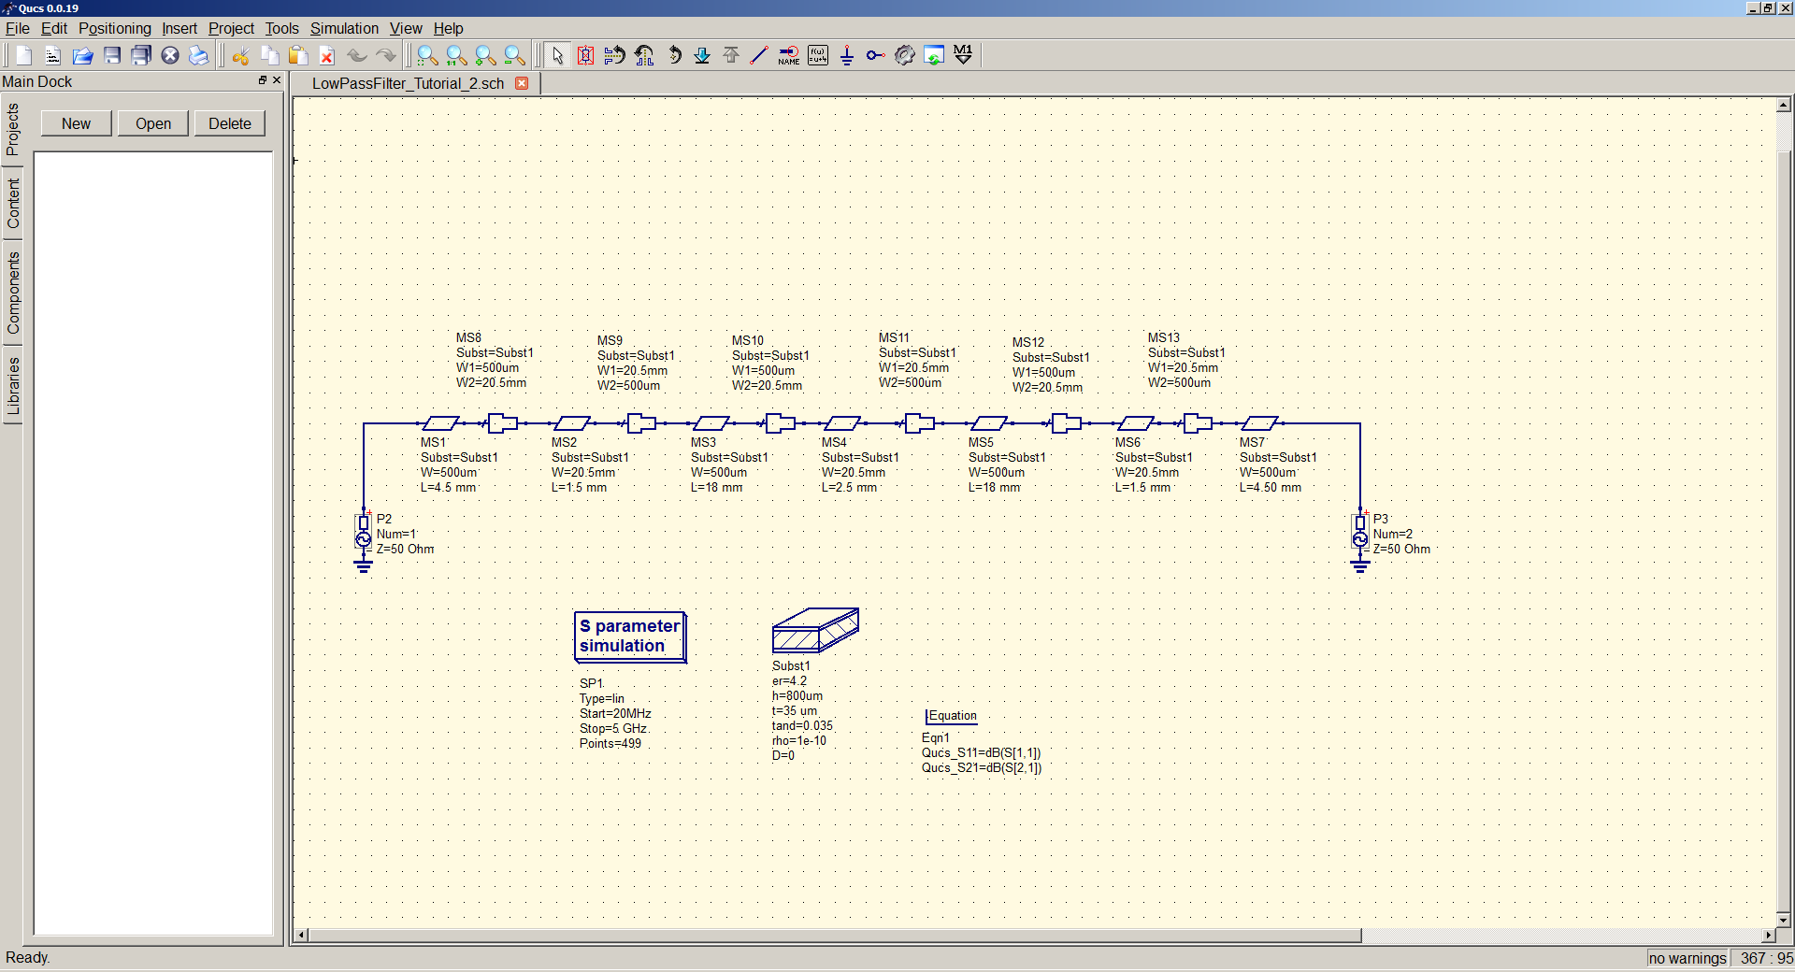Figure 1: QUCS microstrip filter initial design
Simulate circuit to get some referent result which should be similar to simulation from openEMS. Result of this simulation is on picture below.
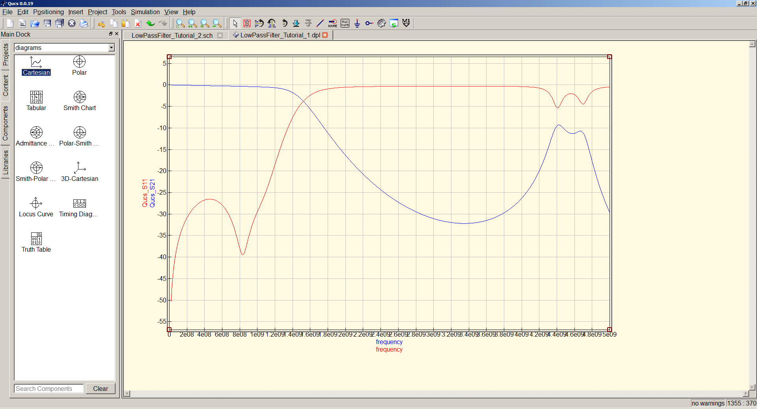Figure 2: QUCS microstrip simulation S11, S21 results

QUCS to KiCAD to FreeCAD conversion
Now we have initial filter design and simulation and need to get it into FreeCAD somehow. For this I used small application to convert Qucs schematic into PCB layout for KiCAD.
To make QucsRFLayout working properly path to Qucs binaries must be set in SYSTEM PATH, because it’s calling Qucs and if it’s not set there is ERROR.
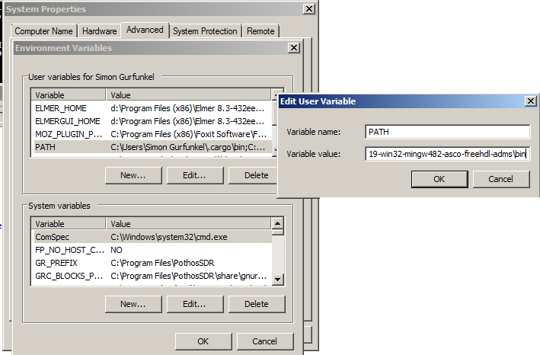Figure 3: Setting path to Qucs binary into system PATH variable in Windows
Run QucsRFlayout and point it into your qucs file with filter design, read it and then export as KiCAD PCB.
Figure 4: QucsRFlayout export microstrip filter as KiCAD PCB
After succesfull export open file in KiCAD PCB editor.
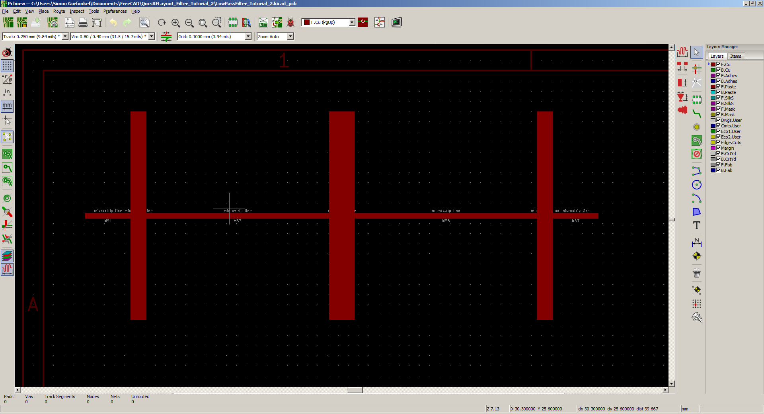Figure 5: Exported PCB design from Qucs in KiCAD PCB editor

Now export PCB copper layer as SVG to be possible to load it into FreeCAD properly.
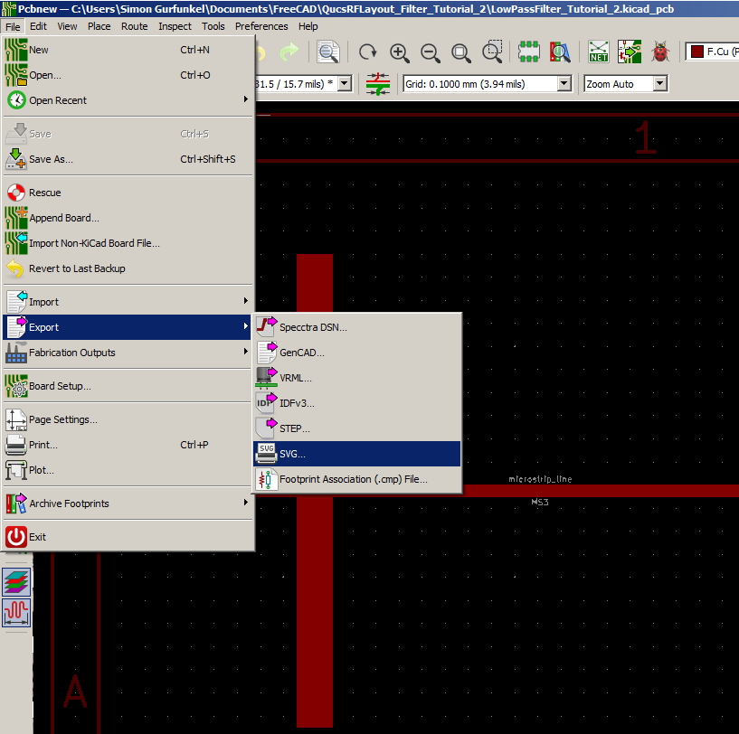Figure 6: Export KiCAD copper layer as SVG
Figure 7: Export just copper layer to SVG file
Open FreeCAD and create new document. Then import planar filter SVG file.
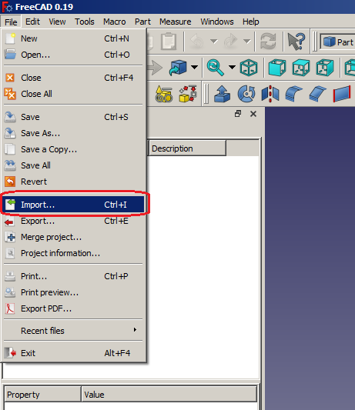Figure 8: Importing SVG into FreeCAD
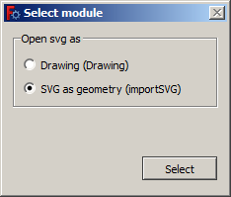Figure 9: Importing SVG into FreeCAD as SVG
If there is some message about resolution just confirm it or whatever, I haven’t pay attention to this I needed to get curves into FreeCAD be imported.

You should got copper layout imported in FreeCAD view, on my monitor it looks like on picture below. Each rectangle part of filter is imported as open path, next steps will convert these paths into faces and whole filter model will be created inside FreeCAD.
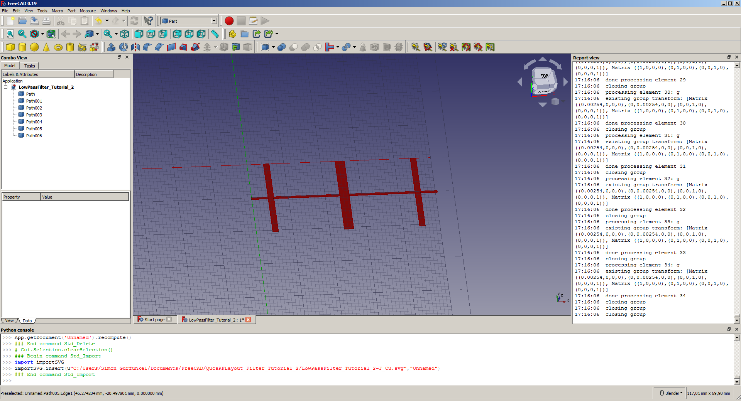Figure 10: Copper layout imported in FreeCAD, SVG is imported as open path into FreeCAD.
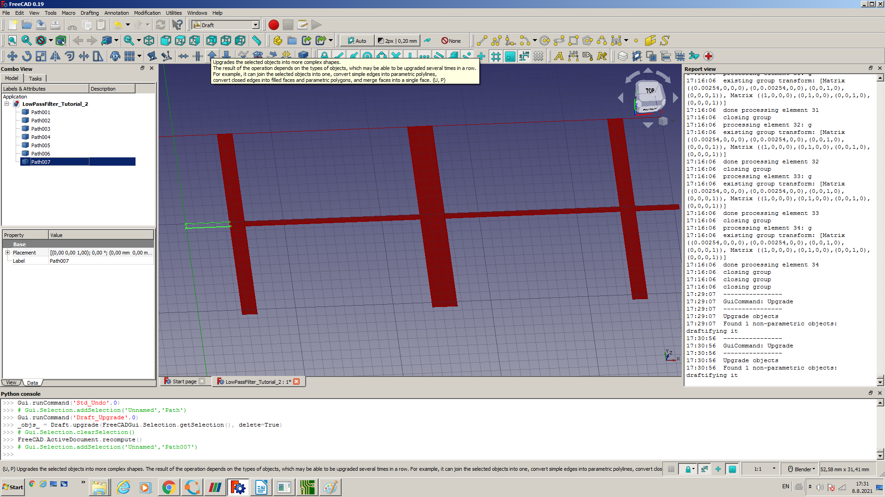Figure 11: Second Upgrade operation needed to convert path into face in FreeCAD
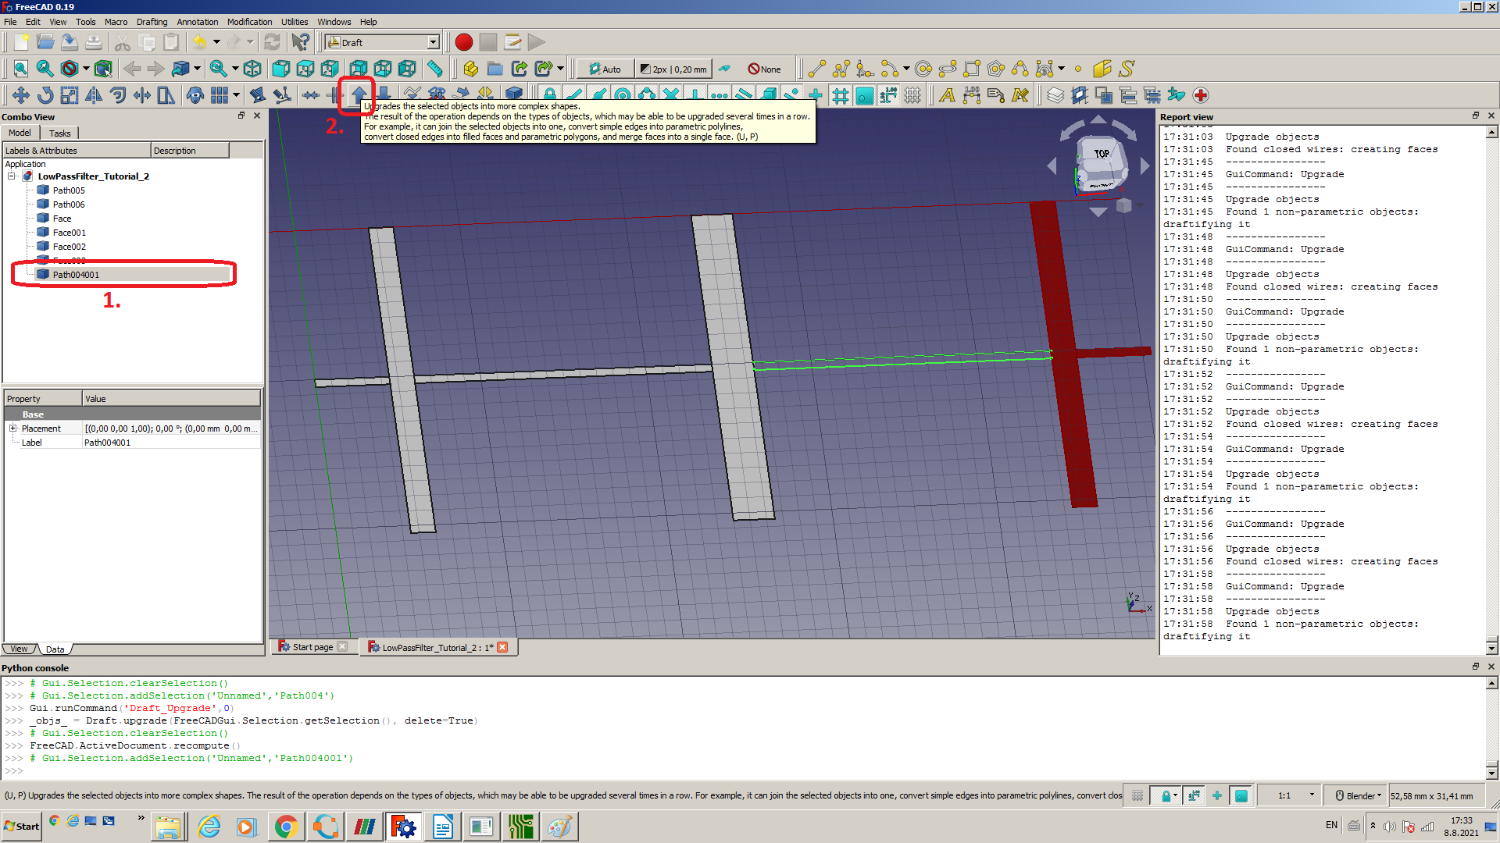Figure 12: Repeat Upgrade process in Draft view for every path in document to convert all to faces
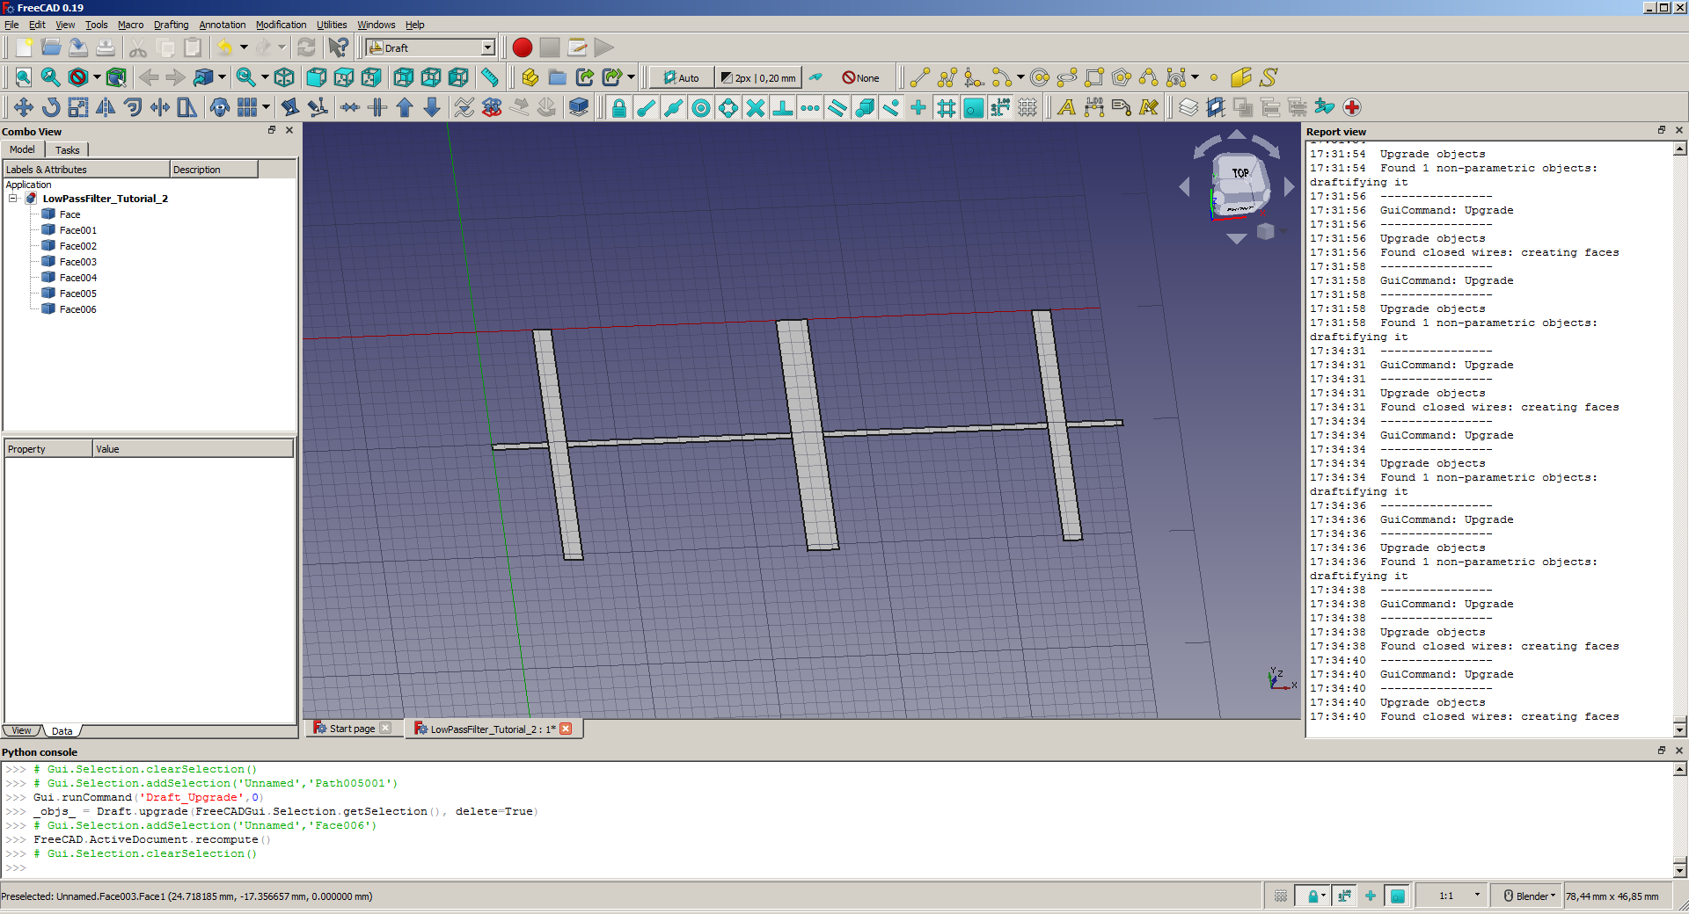Figure 13: All path converted into closed paths and after to faces, this is how it should looks like
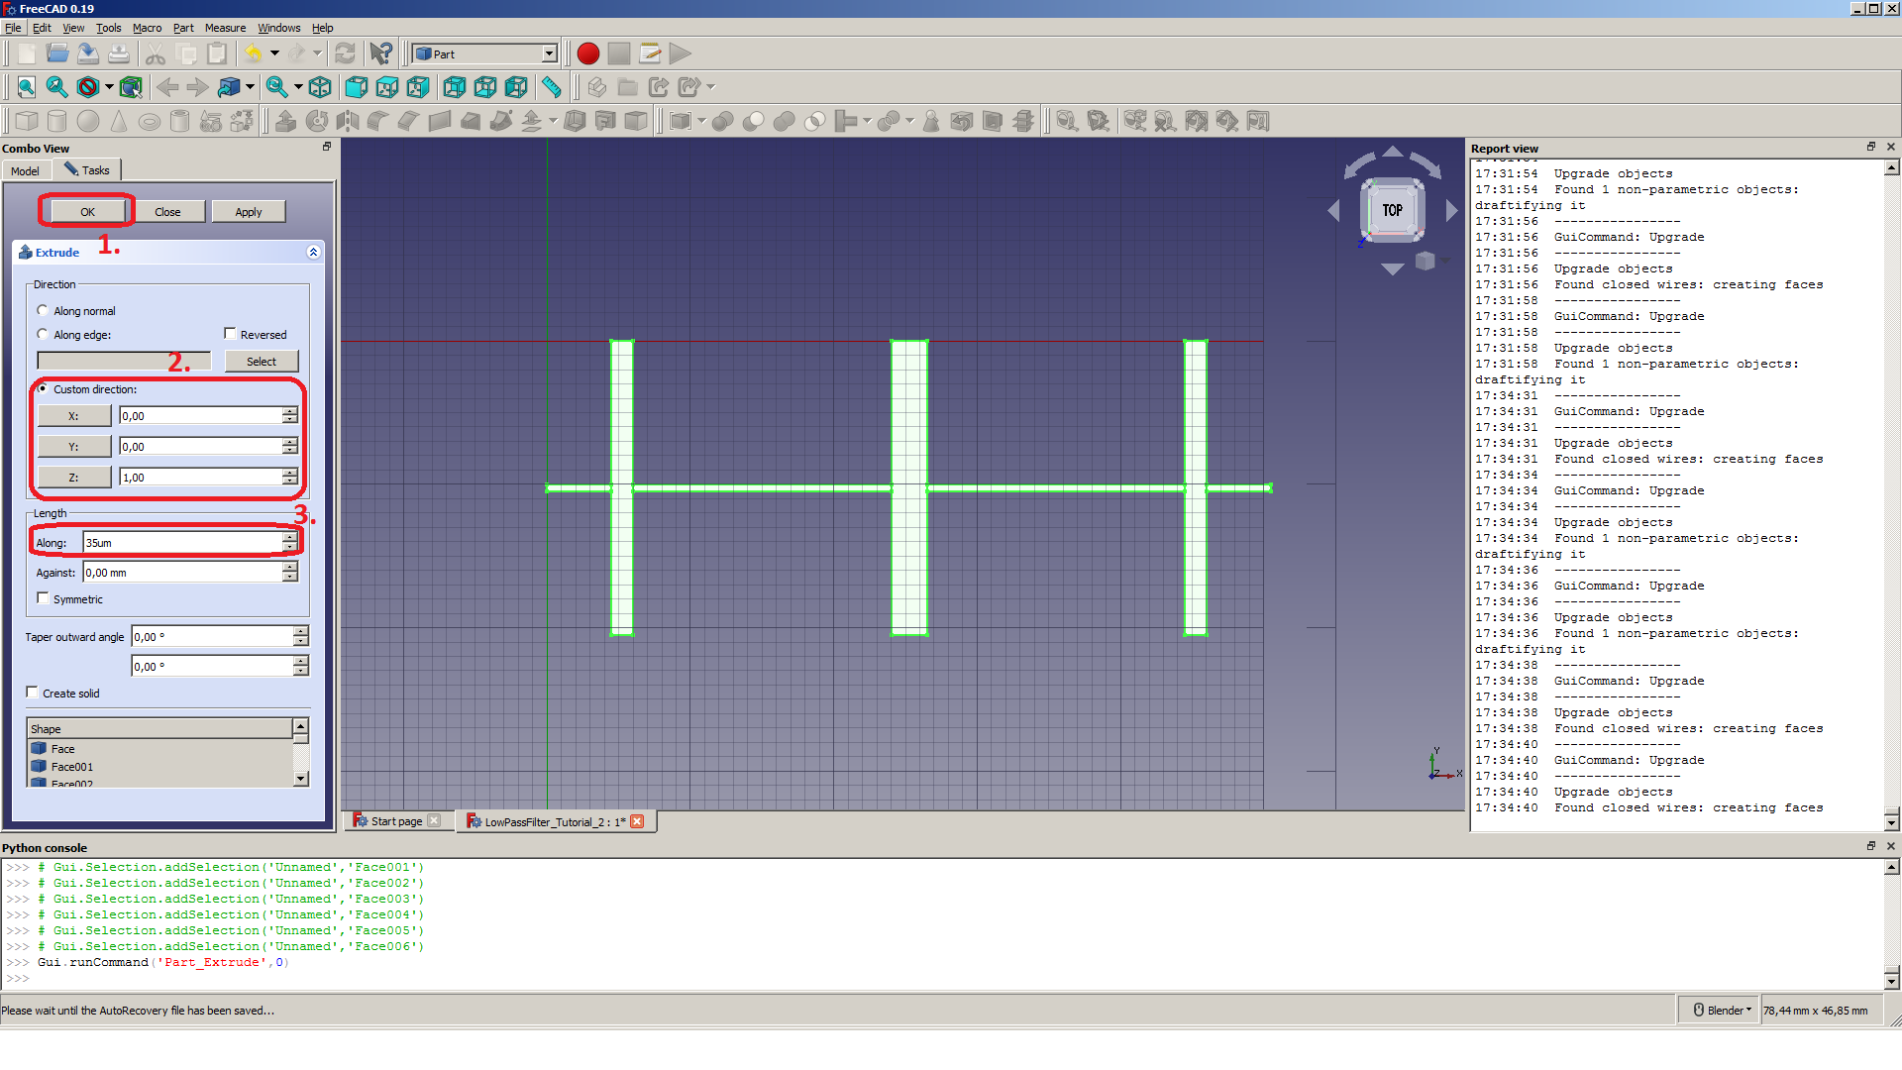Figure 14: Extruding copper layer of filter to 35um same as it is in reality

Modelling filter in FreeCAD
Now we have imported filter copper layer into FreeCAD and extruded it into real copper layer with 35um thickness. Now we have to model rest of the filter how it will looks like in real to be able crete openEMS simulation using FreeCAD to OpenEMS Export Plugin.
So what left to us:
- create PCB model including substrate and gnd
- create input and output port
- create air model around filter to get right simulation results
- setup export plugin

Modelling planar filter in FreeCAD
Now we have successfully imported planar filter designed in Qucs into FreeCAD and convert copper layer to FreeCAD object so we can start to create real model.
First we model substrate, so create rectangle around copper layer using sketch.
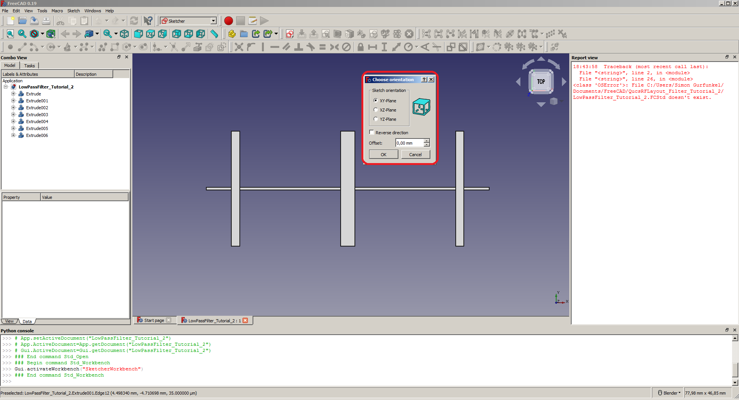
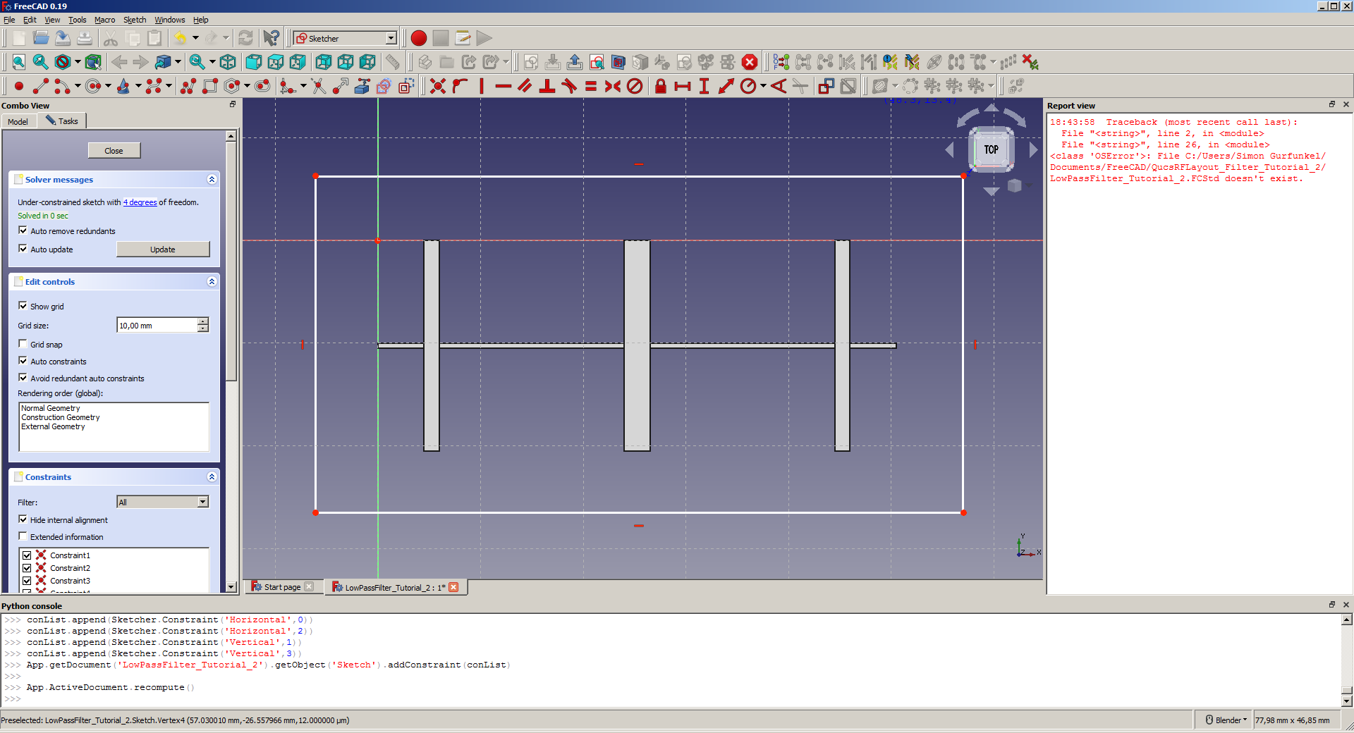
Then extrude sketch in Z direction but reverse it to create substrate with thickness 1.5mm and rename extruded object as substrate.
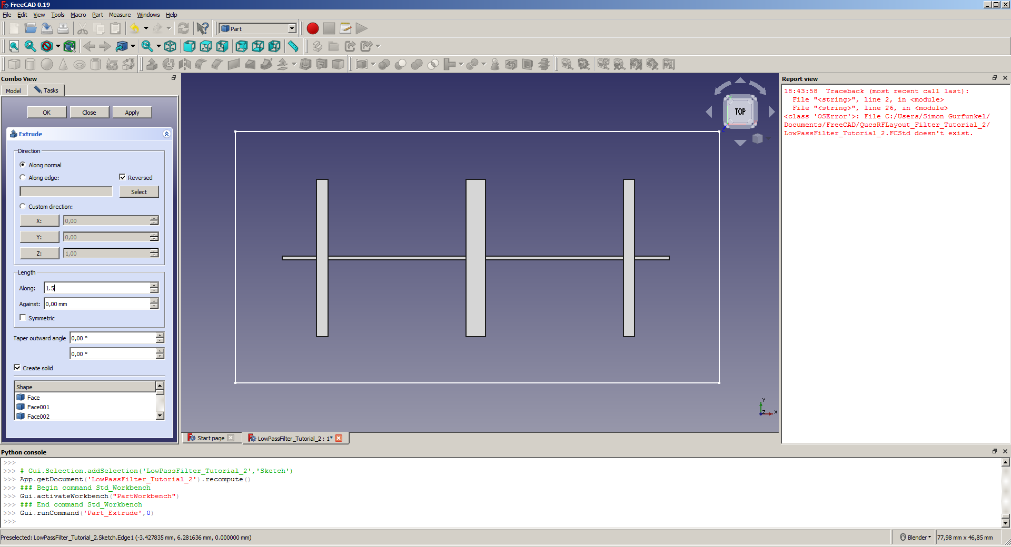
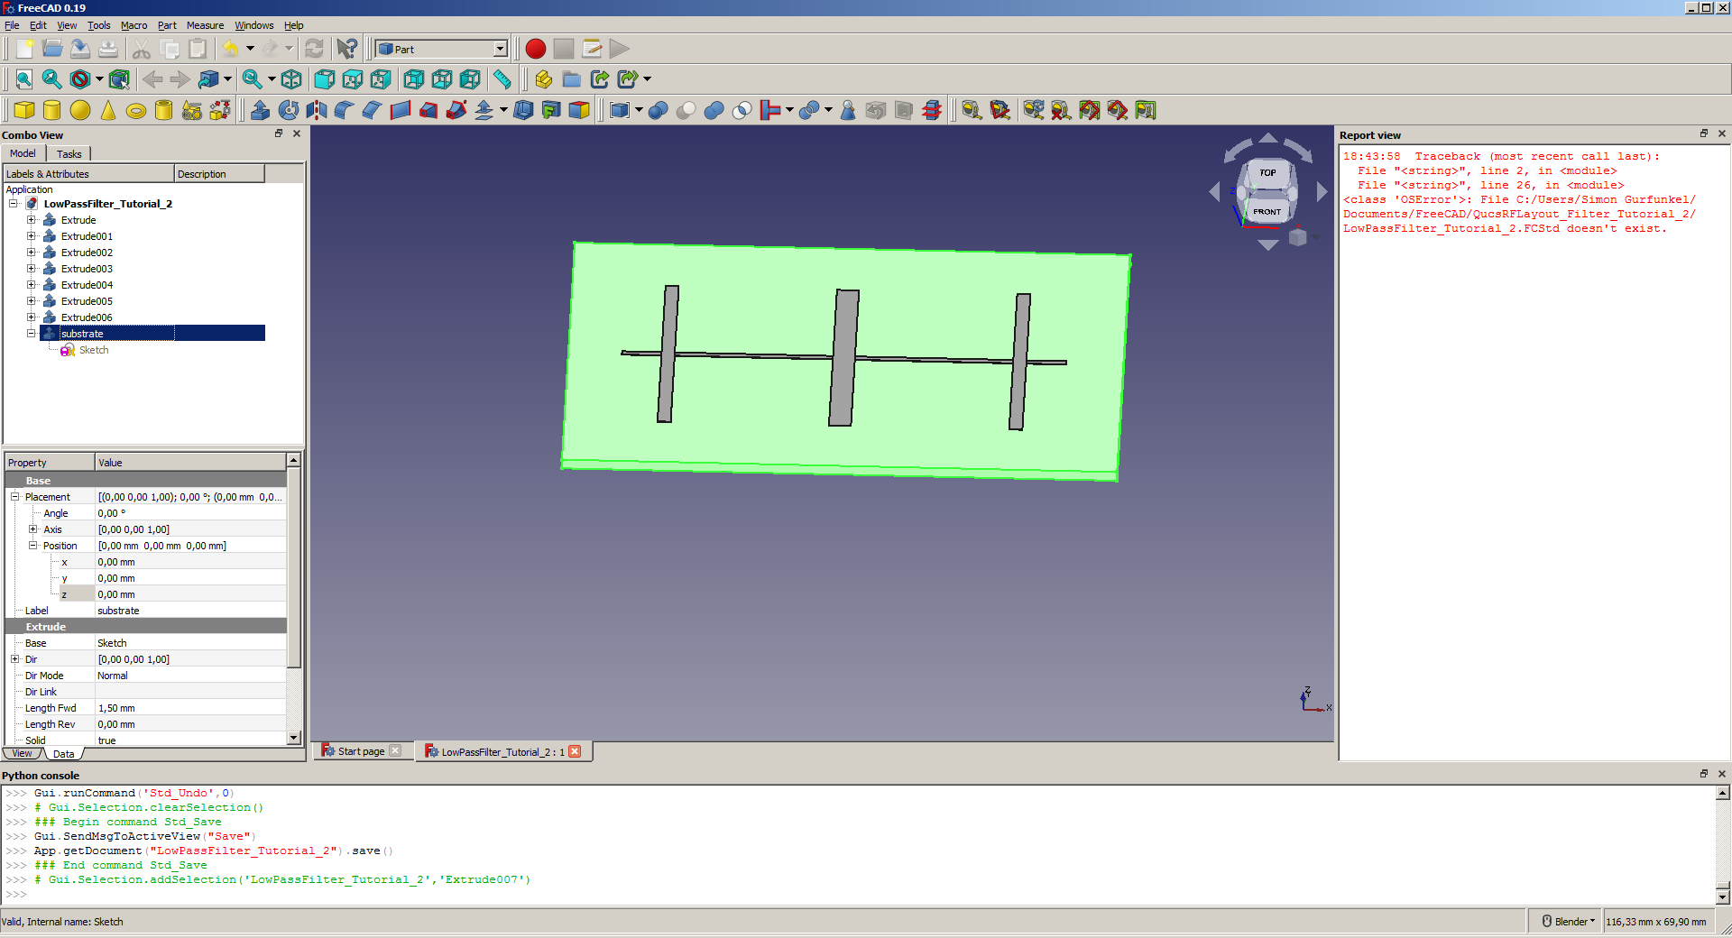
We will use sketch for substrate to create ground plate. Select sketch located in model treeview under substrate and again choose extrude tool.
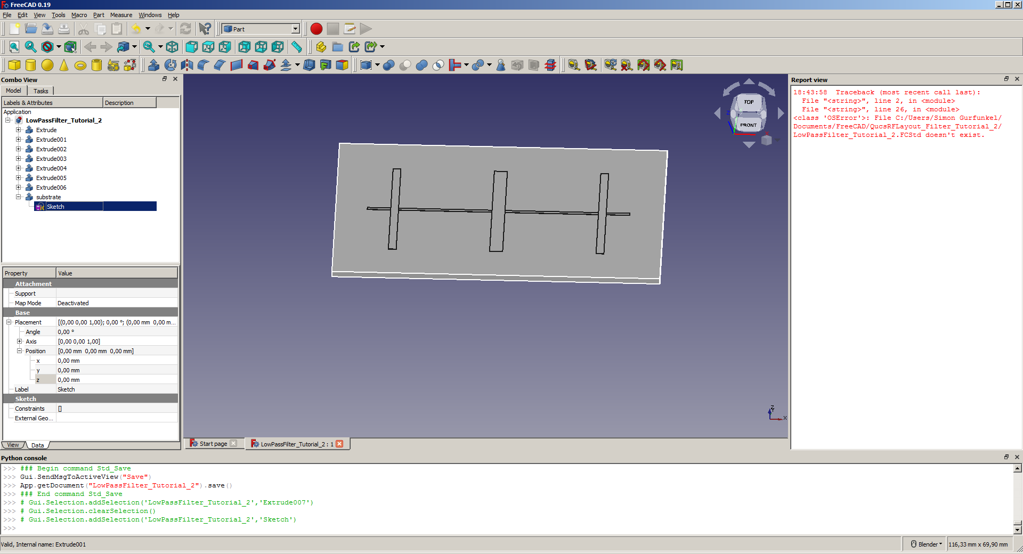
Set parameters as on picture below, extrusion length to 35um which represent ground copper layer and reversed direction.
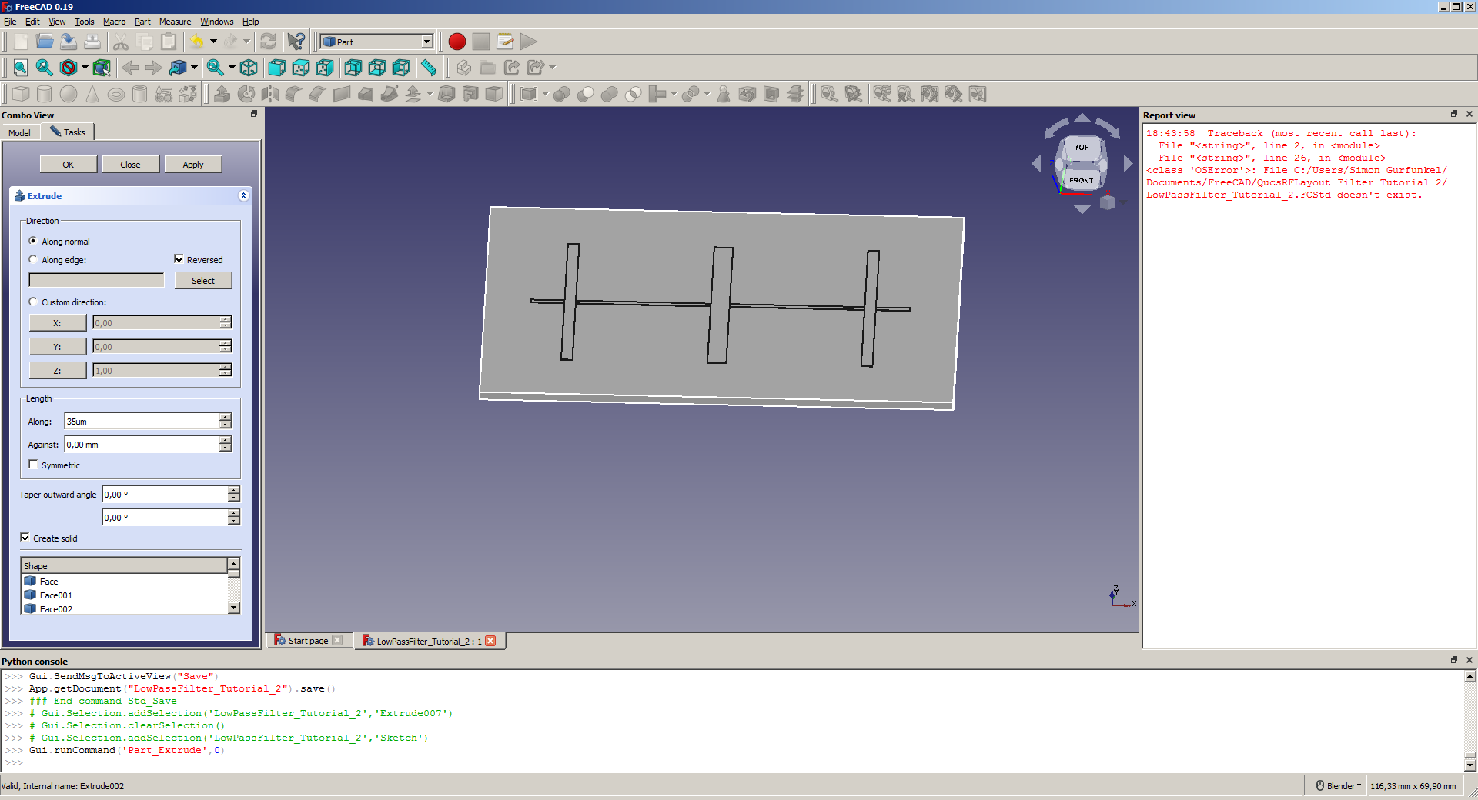
Now renamed extruded object to name gnd and set its position as -1.5mm to move it below substrate.
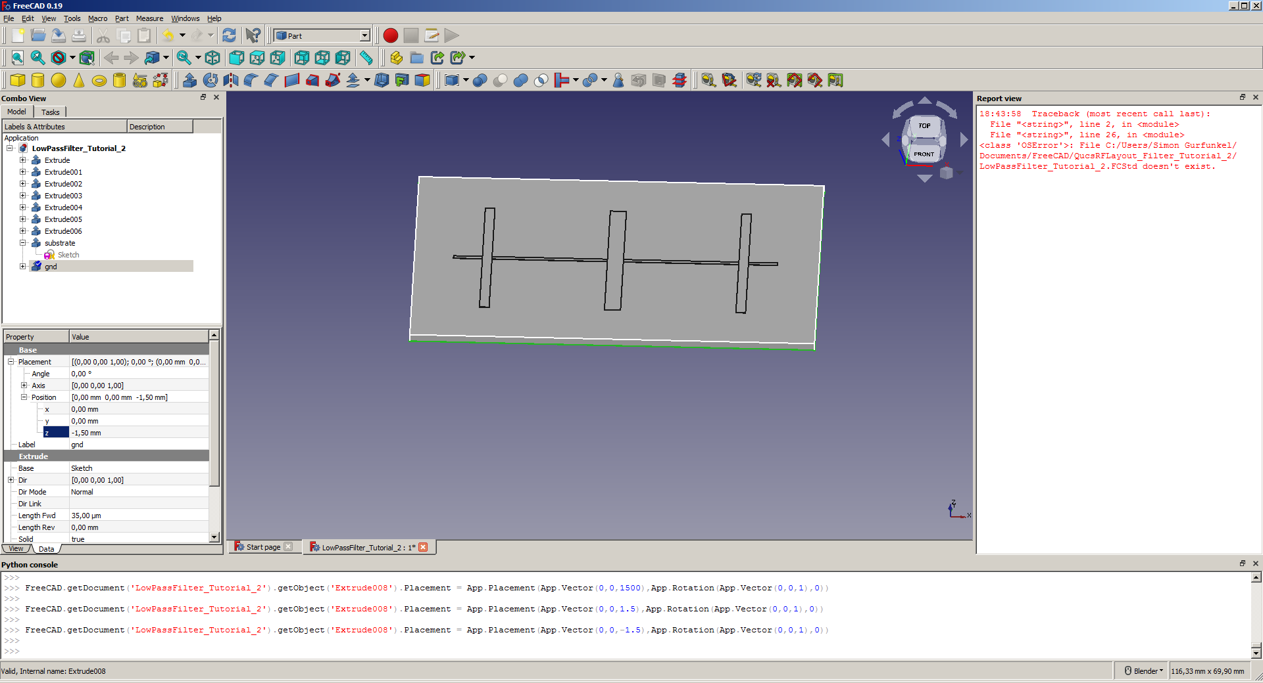
At this point we have planar filter model already ready. We must create input and output port which will be made using two boxes, one in left filter part and second in right part.
Select left filter copper face and from sketcher choose create sketch as shown below.
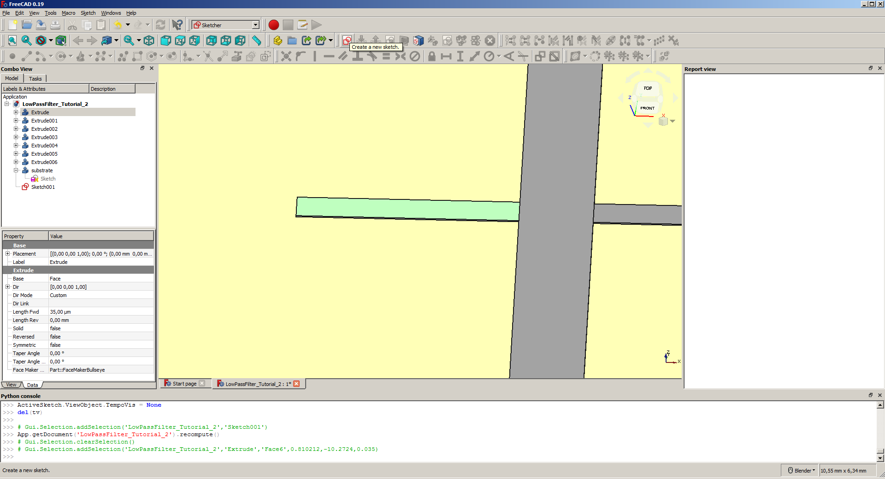
Draw rectangle, it will be input port for our simulation. You don’t have to really care about its dimensions, there would be later defined just one line going through this inpt port.
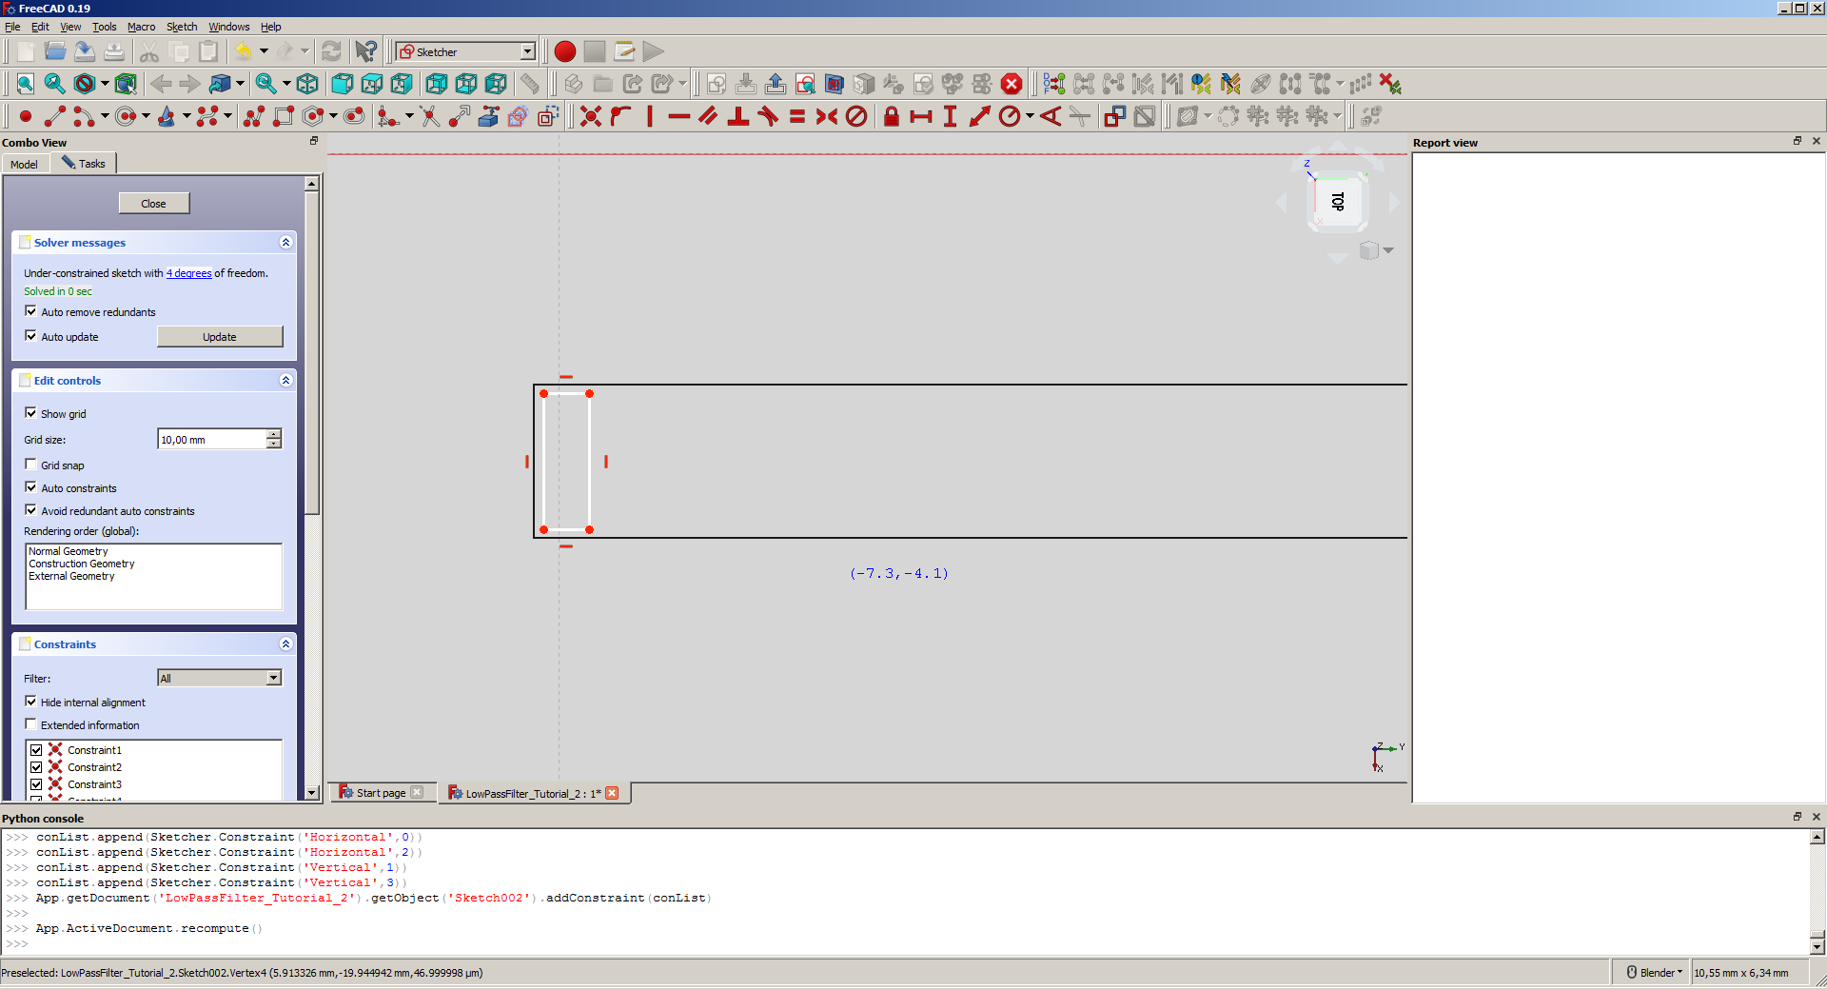
Now extrude box in reversed direction for 1.57mm (that’s 1.5mm for substrate and 2*35um for top copper filter part and gnd plate).
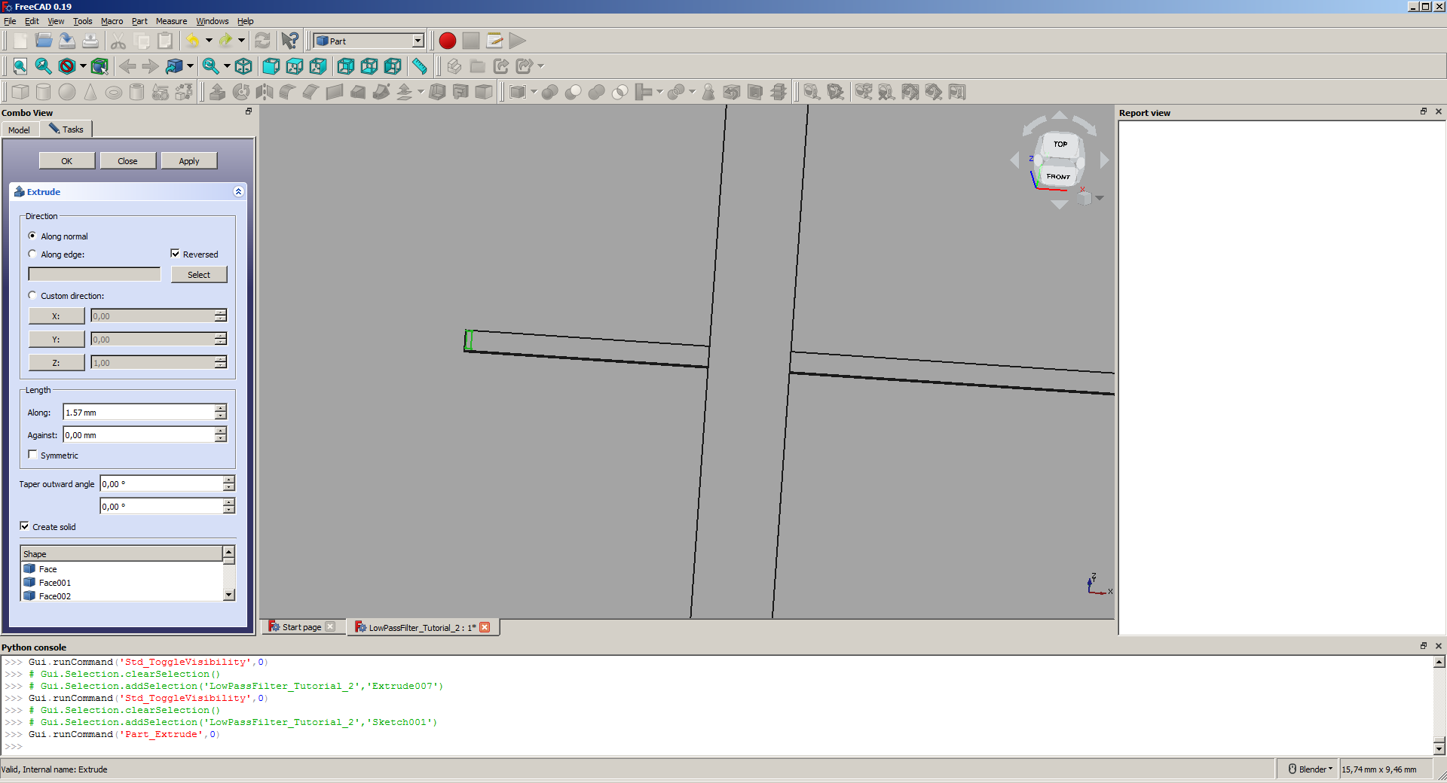
Now your model should looks like this.
